The Trauma Recovery Network gets referrals on-line or through our 1800 455 076 number, which we then register on-line. You will get a form with the persons name, DOB, location and contact details. We promise that they will be contacted within 48 hours and ask that you make initial contact as soon as possible to set up appointment times. You can find the “Pocket Guide for early EMDR intervention” at www.tramarecovery.network/resources/

For research and evaluation, we ask that you provide assessments at the beginning of every session to track progress. By doing every session we will always s have the first and last assessment regardless of when they finish treatment or drop out.

You can assess the client in your office using an IPad, logging into your Novopsych account. Or you can send the assessment to your client by email and they can answer the questions on their IPhone in your office or before they attend an online or personal appointment. The results will come back to you immediately.

To begin the evaluation, go to novopsych.com.au and log-in with your email address.

To administer in your office, see instructions on-line:

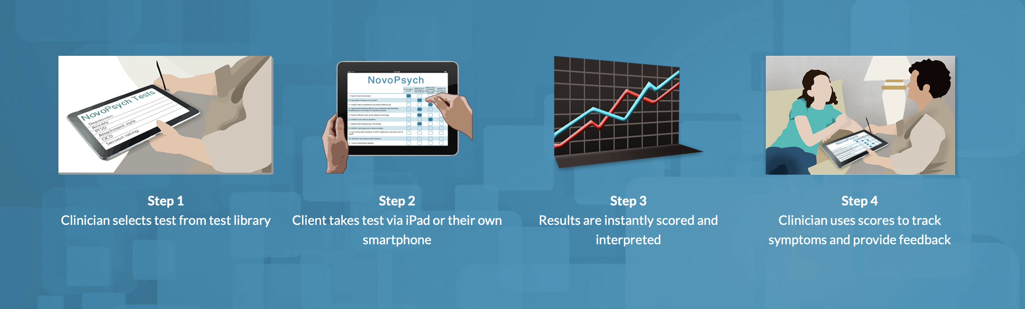
For sending email assessments:

1. On top line, open “clients” tab, then click on “Add Client”, put in client details, click add client

2. Screen for new client appears, click on “email” button.

3. Add the following tests:
1. TRNC – Trauma Recovery Network Consent Form
2. PCL-5 – Post Traumatic Checklist DSM 5
3. PHQ – 9 – Patient Health Questionnaire
4. Send to client – they can fill out on phone or computer.
5. At last session, add Client Satisfaction Survey

If the client does not have access to the internet, you can ask the questions verbally and register them online yourself. All data is kept in a secure and independent TRNA account in Novopsych.

Billing:

The Medicare items for Bushfire Recovery are at www.traumarecovery.network/resources/ and are valid until 31 December 2021.

Data Collection Process Map Summary

RECRUITMENT
Psychologist enrols into TRNA Project
TRNA send Psychologist email to Novopsych
TRNA send instructions to Psychologist
TREATMENT DELIVERY
Psychologist loads the TRNC (Consent Form), PCL-5 & PHQ-9 onto clients Novopsych file
FIRST SESSION
Psychologist emails link of TRNC, PCL-5 & PHQ-9 to client. Client completes Consent Form, PCL-5 & PHQ-9 in session & Psychologist provides feedback about baseline
Psychologist loads the PCL-5 & PHQ-9 onto clients Novopsych file

FURTHER SESSIONS
(3 – 6

Psychologist emails link of the PCL-5 & PHQ-9 to client. Client completes Consent Form, PCL-5 & PHQ-9 in session and Psychologist provides feedback of treatment progress

Psychologist loads the Client Satisfaction Survey (CSS), PCL-5 & PHQ-9 onto Novopsych file

LAST SESSION
Psychologist emails link of CSS, PCL-5 & PHQ-9 to client. Client completes CSS, PCL-5 & PHQ-9 in session & Psychologist provides feedback about their final results from treatment then discharge

DROP - OUT
Psychologist unable to contact client

UNSUCCESSFUL CONTACT

Psychologist follows up & speaks to client by phone
SUCCESSFUL CONTACT
Client wants to return for a last session.
Client does not want to return for a last session. Psychologist emails link of CSS, PCL-5 & PHQ-9 to client then discharge

Psychologist emails link of CSS, PCL-5 & PHQ-9 to client then discharge
FOLLOW-UP
Psychologist schedules the PCL-5 & PHQ-9 onto clients Novopsych file. Psychologist selects start date as the date of discharge, selects repeat every 3 months and selects 3 cycles. Psychologist selects “Administer” to automate follow-up administrations

